**ODIN II**

**REQUIREMENTS**

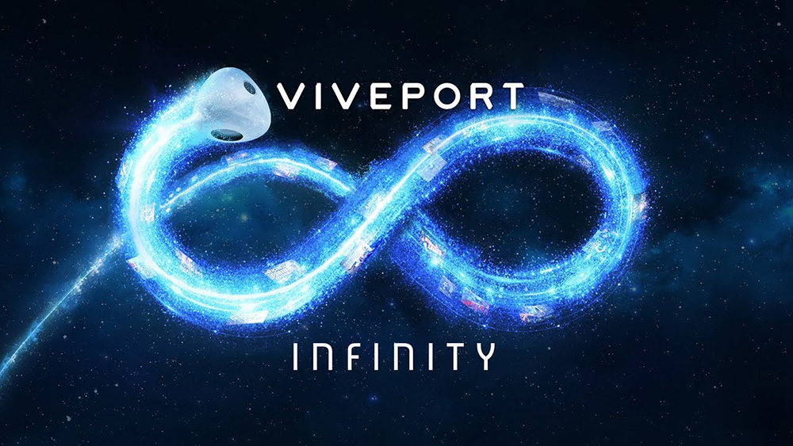

TEAM 11

TODD TOWNSEND, ABRAM FOUTS, KARLA BARRAZA LOPEZ, WENHAO CHENG, XUENING JIA

Sponsor: Brad Smith - Intel Corporation

Advisor: Fu Li

# REQUIREMENTS

**1. Functional Requirements:**

|  |  |  |  |
| --- | --- | --- | --- |
| Requirement # | Requirement | Priority | Station Location |
| 1.1 | Host Environment in Unity | Must | Host |
| 1.2 | Port FOVE to HTC Vive Pro Eye | Should | Peripheral Component |
| 1.3 | Gaze Vector Hook | Must | Software |
| 1.4 | Touch Controller Hook | Must | Peripheral Component |
| 1.5 | Host the program within SteamVR | Must | Software |
| 1.6 | Field of View Hook | Should | Software |

** Highlighted in yellow have been changed from must’s to should’s because of COVID-19.

**2. Performance Requirements:**

|  |  |  |  |
| --- | --- | --- | --- |
| Requirement # | Requirement | Priority | Station Location |
| 2.1 | Integrate Host with VR Headset | Must | Host |
| 2.2 | Correction/Cure of strabismus through the use of VR | Should | Host/Peripheral |

**3. Economic and Marketing Requirements:**

|  |  |  |  |
| --- | --- | --- | --- |
| Requirement # | Requirement | Priority | Station Location |
| 3.1 | HTC VIVE Pro Eye Platform | Must | Host |

**4. Power Requirements:**

|  |  |  |  |
| --- | --- | --- | --- |
| Requirement # | Requirement | Priority | Station Location |
| 4.1 | 12 Volt Power Supply | Must | Host |
| 4.2 | USB Power Supply | Must | Peripheral Components |

# 